ADDRESSING SLOW/LAG SYSTERM PERFORMANCE ISSUE:

1. You may also refer to these url link guidelines for additional TS executions,

[13 Tips to Windows 10 Very Slow and Unresponsive (minitool.com)](https://www.minitool.com/backup-tips/windows-10-very-slow-and-unresponsive.html)

[Top 7 Solutions to Service Host Local System High Disk Windows 10 (minitool.com)](https://www.minitool.com/backup-tips/service-host-local-system-high-disk.html)

1. Increase and maxing out core processors:

* Run cmd as admin or run a different user, then input admin user login.
* In cmd, type in msconfig then enter.
* In Msconfig window settings, click Boot in the upper menus then click Advance options (see sample screenshot below)

* In Advance options, tick number of processors then, select your desired number of cores to be utilize. (see shown picture below). Then click Ok button.

* Click Apply button. It will prompt you to this screenshot below. Just click Yes to proceed, then Ok. (it will require you to restart the computer after but, you may choose to restart later if plan to delay the restarting of pc)

1. Increase and maxing out to its exceed limit of your RAM Virtual memory speed:

* Run cmd as admin or run a different user, then input admin user login.
* In cmd, type in sysdm.cpl then enter.
* Type **View advanced system settings** in the search box of Windows 10 and choose the best-matched one.
* In the **Advanced** tab, click **Settings** under **Performance** section.

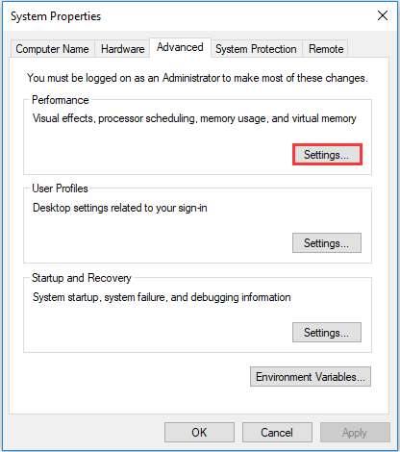

* Switch to **Advanced** tab, click **Change** under **Virtual memory**section.

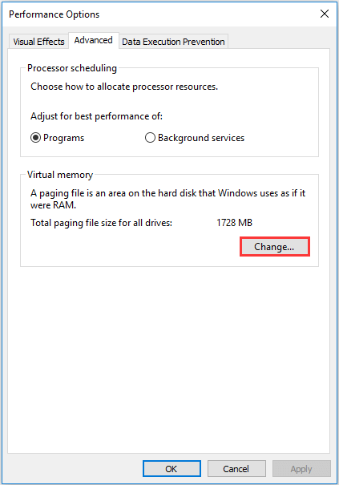

* Uncheck **Automatically manage paging file size for all drives**, select the drive, choose **Custom size**. Then input the **Initial size** and **Maximum size**. At last, click **Set** and **OK** to save the changes.

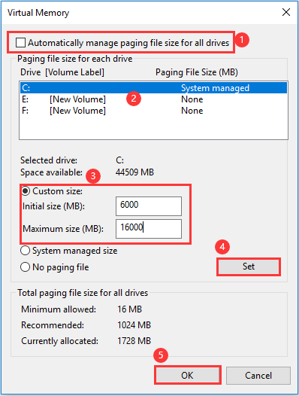

* After that, you will set the size of virtual memory for that drive. In order to solve the Windows 10 very slow and unresponsive issue, you need to set the manual size for all drives. Then reboot your computer to check if the issue of computer running slow is fixed.
* **Note:** As for the size of virtual memory, it is related to the size of your RAM. As a general rule, the Initial size should be at least 1.5 times larger than the amount of RAM memory on your PC. As for the maximum size, it should be up to 4 times larger than the amount of RAM on your PC.

1. Uninstalling either Forcepoint DLP and/or Fire eye program installed specially for Fujitsu E5510 series. Depending on what program that might highly affecting the disk utilization process.

END